CVM Veterinary Medical Diagnostic Laboratory Submission Form
1-800-UMC-VMDL 800-862-8635 Fax 573-882-1411
Courier Address www.vmdl.missouri.edu US Mail Address
VMDL, 810 E. Campus Loop, Columbia, MO 65211 VMDL, PO Box 6023, Columbia, MO 65205

Acct No _____________ □ Email _______________________ Date Sample Taken _________ Date Sent ________
Phone ___________________ □ Fax ____________________ Owner_____________________________________________
Veterinarian ________________________________________ Address ____________________________________________
Clinic _______________________________________________ City ___________________________ State ___ Zip ________
Address__ ___________________________________________ Phone _______________________________
City ________________________ State______ Zip __________
Animal Tag/ID_________________________Species ________________ Breed __________________ Sex_______ Age________ Weight___
# in Group ____ Sick ___ Dead __ Raised on Premises? ___If purchased, when?_______ New introductions? __ Date Introduced ____
Date noticed sick ________ Euthanized? ____ Method of euthanasia ______Time/ Date of Death ______
Presenting complaint/Systems of interest: Choose as many as apply.
□Normal | □Fever | □Neurological | □Hepatic | □GI/Diarrhea
□Abortion/Repro Failure | □Endocrine | □Sudden Death | □Urinary/urogenital | □Musculoskeletal/lameness
□Edema | □Ocular | □Neoplasia/Mass | □Chronic weight loss | □Cardiac
□Respiratory | □Anorexia | □Dermatological | □Production/performance | □Hematological/Hemorrhage
□Erosion/Vesicular | □Other_________________ |  | decline
Clinical/Differential Diagnosis: ________________________________________ Additional History: ___________________________________
______________________________________________________________________________________________________________________
______________________________________________________________________________________________________________________
□ Necropsy Exam □ Necropsy+Histopathology □ Necropsy+Histo with Laboratory Tests □ Abortion Panel □Toxicology (additional fees)
□ Biopsy □ FA Diarrhea panel-feces □ FA Diarrhea panel–tissues □ FA Respiratory panel
□ Mail-In Necropsy with Lab Tests*There may be an additional fee for MULTISYSTEMIC (enteric AND respiratory) exam of mail-in and necropsy specimens.*
*Duration ________________*Margins inked/Tagged?_______*Treatment________________________ When started/how long? ______________ Response to therapy? _ yes _ no _ partially. If tumor, Size ____ Duration ________ Rate of growth ___ slow ___ fast Recurrence ___yes ___no
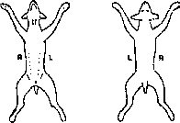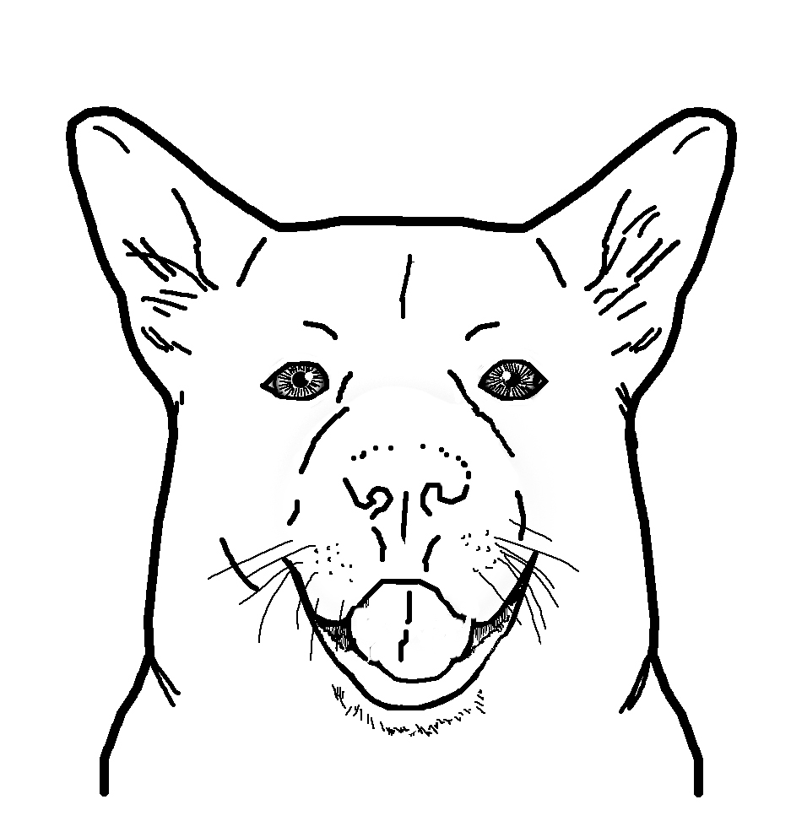
Sample type
□Tissue, Fresh | □Blood
□Tissue, Fixed | □Serum
□Feces | □Urine
□Other_____________

Circle lesions mark “X” for biopsy locations
Cytologic Exam—Label slides with animal ID & site. Pertinent clinical information: _________________________________________________ ________________________________________________________________________________________________________________________________________________________________________________________________________________________________________________
□ Cytology - List site(s) _____________________________________________________________________________________________
Circle Collection Method: Washes Aspirates Imprints Brushes Scrapings Other ___________________________
□ Multiple Lymph Node Cytology (2-4 Lymph Nodes) – List site(s) ___________________________________________________________
_____________________________________________________________________________________________________________________
□ Fluid Analysis, including Cytology – Send Fluid in an EDTA tube along with slides □ CSF Analysis – Call for instructions
Circle fluid type: Pleural Peritoneal Synovial Pericardial □ Bronchoalveolar Lavage -- Send Fluid in an EDTA tube along with slides

Bacteriology □ Feces □ Swab from __________ □ Tissue from __________ □ Urine: __Cystocentesis __Free Catch □ Other ______
□ Aerobic bacterial culture with up to 3 susceptibilities (fixed price and MUST select before tests run)
□ Aerobic culture □Anaerobic culture □ Antimicrobial susceptibility □Enteric screen (bovine, canine, porcine) □ Fungal culture □ Abortion screen □ Blood culture □ Salmonella □ Johne’s culture □ Johne’s direct PCR fecal Tritrichomonas foetus □ PCR or □ culture
□ Other _____________Treated with antibiotics recently? Y/N Antibiotic used, when, and last dose______________________________

Toxicology □ Feed___ □ Blood __□ Serum__ □ Fresh Tissue__ □ Other_________________ □ Consult Toxicologist
□ Aflatoxin in milk and liver □ Ammonia □ Calcium serum; ocular fluid □ Cholinesterase activity whole blood, brain □ Copper □ Ergot Alkaloids in feedstuffs □ Ergot/Fescue Alkaloids in feedstuff □ Lead □ Magnesium serum and ocular fluid □ Mycotoxin Screen □ Nitrate –feed –ocular □ Rumen pH (included with necropsy) □ Vitamin E □ Other__________________

Rabies testing: □ Brain only □ Entire body with brain removal & carcass disposal [send out] □ Chronic Wasting Disease (CWD) [send out]
Lab use only □ Cold Pac □ Frozen □ None □ Room Temp. Sample Condition □ Broken □ Leaked □ Other _________________

**Clients submitting specimens are considered to have agreed to VMDL testing procedures, policies and fees (view at: http://www.vmdl.missouri.edu/).
Specimens become the property of the VMDL.
Tube/Name/No. Species Breed Sex Age Tube/Name/No. Species Breed Sex Age
1 |  |  |  |  |  |  | 3
2 |  |  |  |  |  |  | 4
PCR Panels

Bovine Enteric : Bovine Coronavirus, Rotavirus and BVD I & II □
Bovine Pink Eye : IBR, Mycoplasma bovis, Mycoplasma bovoculi □
Bovine Respiratory : BVD I & II, BRSV,PI3, IBR □
Canine Respiratory Panel : Canine Distemper Virus, Influenza A, Canine Adenovirus □
Equine Enteric : Salmonella, Lawsonia, Potomac Horse Fever (EDTA blood and feces) □
Equine Enteric: plus Clostridium difficile toxin A&B ELISA and
Clostridium perfringens ELISA (call for instruction) □
Porcine Enteric 1 (young pigs) Delta Coronavirus, PEDV, Rotavirus A, TGEV □
Porcine Enteric 2 (older pigs) Brachyspira spp., Lawsonia intracellularis,
Salmonella spp. □
Porcine Respiratory : PRRSV, PCV2 Influenza A Mycoplasma hyopneumoniae □

Serology (1 ml serum, redtop or separator tube) PCR/Virology (EDTA whole blood, CNS fluid, swabs, tissue, feces or as noted)

Anaplasma phagocytophilum(K9, Fel)□ IFA □ PCR

Anaplasmosis □ ELISA □ PCR

Aspergillosis □ AGID

Blastomycosis □ AGID

Blastomycosis and Histoplasmosis □AGID

Bluetongue □ ELISA □ PCR

Borrelia burgdorferi (Lyme Dz) □ IFA □ PCR

Bovine Coronavirus □ PCR

Bovine Leukosis □ ELISA □ PCR (EDTA blood)

Bovine Respiratory Syncytial Virus □ PCR

Brucella canis □ Card

BVD (Bovine viral diarrhea) testing options:

IHC (up to 6 fixed ear notches per slide) □

Herd screen serum or fresh ear notch ELISA □

PCR (tissues, feces or EDTA blood) □

Serum neutralization (serum) □

Brachyspira spp. □ PCR

Brucella □ Card

Canine Coronavirus □ PCR

Canine Distemper □IgG antibody (IFA)

□ IgM (IFA) □PCR

Canine Distemper Parvo Titer □ ELISA

Canine Heartworm □ ELISA

Canine Parvovirus □ IgG antibody □ IgM

antibody □ PCR

Chlamydophila psittaci □ PCR

Coccidiomycosis □ AGID

Cryptococcus □ Antibody □ Antigen-LA

Ehrlichia spp. □ IFA □ PCR

Enteric virus □ Electron microscopy

Equine Herpesvirus □SN □ EHV 1&4 PCR

Equine Infectious Anemia (EIA) □

Equine Viral Arteritis □ ELISA □ SN

Epizootic Hemorrhagic Disease Virus

(EHD) □ AGID □ PCR

Feline Calicivirus □ Virus Isolation

Feline Heartworm Antibody □

Feline Herpesvirus □ PCR

Feline Infectious Peritonitis (FIP) □ IFA □ PCR

FIV Antibody and FeLV Antigen – □ Snap test

Feline Leukemia Virus - □ FA

Histoplasmosis □ AGID

Infect. Bovine Rhinotracheitis(IBR)□ SN□ PCR

Influenza A □ PCR

Johne’s □ ELISA (serum) □ PCR (feces)

Lawsonia intracellularis □ PCR

Leptospira □ MA (6 serovars) □ PCR

Mycoplasma □ PCR w/sequencing

Mycoplasma bovoculi □ PCR

Mycoplasma hyopneumoniae □ ELISA □ PCR

Neospora □ ELISA

Parainfluenza 3 □ SN □ PCR

Porcine Circovirus (PCV2) □ PCR

Porcine Epidemic Diarrhea Virus(PEDV) □ PCR

PRRSV □ ELISA □ PCR

Potomac Horse Fever □ PCR (feces, EDTA)

Pseudorabies (PRV) □ ELISA □ PRV & Brucella

R.rickettsii (RMSF) □ IFA □ PCR

Rotavirus A □ PCR

Salmonella □ PCR

Senecavirus A real time □ PCR

Small Ruminant Lentivirus CAE & OPP □ ELISA

Swine Influenza □ ELISA □ PCR

Tick panel: A. phagocytophilum, B.

burgdorferi, E. canis, and R, rickettsii

□ IFA-serum □ PCR EDTA

Toxoplasma (feline) □ IFA □ PCR

Toxoplasma (all species) □ PCR

TGEV/Porcine respiratory coronavirus □ PCR □ SN

Tritrichomonas foetus □ PCR

(InPouch within 48 hours)

Vesicular Stomatitis □ SN

West Nile IgM (equine only) □ ELISA

West Nile □ PCR

Other: _____________________________

___________________________________ ___________________________________
Chemistry – centrifuge and remove serum/plasma into a separate tube  Specimen type:  □ Serum □ Plasma □ Urine  □ Other _______________  □ MAXI Profile  □ MINI Profile  □ RENAL Profile  □ LIVER Profile  □ Bile Acid Single  □ Foal IgG  □ Electrolyte and Mineral Panel  □ Urine Protein/Creatinine  □ Other ______________  Coagulation—CALL for instructions  □ PT  □ PTT | Hematology  □ CBC (small animal) - Submit EDTA tube & smears (includes fibrinogen in large animals)  □ CBC (large animal) - Submit EDTA tube & smears (includes fibrinogen)  □ Fibrinogen  □ Knott’s test  □ Coombs’ Test  □ Smear Exam for _____________  □ Other _____________  Bone Marrow - submit concurrent  CBC or send recent CBC report  □ Bone Marrow Aspirate  □ Bone Marrow Core Biopsy  Fecal Examination  □ Flotation □ Fecal Occult Blood  □ Cryptosporidium □ Baermann  □ Direct Fecal Exam  Other (specify) _____________________________ | Urinalysis (For Courier/ Local Samples Only) □ Voided □ Cystocentesis  □ Catheter □ Off Floor  □ Complete UA  □ UA w/o Sediment Exam  □ Other (specify) ____________  Endocrinology  □ Total T4  □ TSH (canine)  □ Cortisol – Single  □ ACTH Stimulation –  2 sample  □ Dexamethasone Suppression --  2 Sample  □ Dexamethasone Suppression --  3 Sample  □ Progesterone (1 mL serum)  □ Endogenous ACTH (1 mL EDTA  Plasma) (Equine)

Clinical Pathology must provide Date Sample Taken ___________________________

