CVM Veterinary Medical Diagnostic Laboratory Food Animal Submission Form
1-800-UMC-VMDL 800-862-8635 Fax 573-882-1411, www.vmdl.missouri.edu
Courier Address US Mail Address
VMDL, 810 E. Campus Loop, Columbia, MO 65211 VMDL, PO Box 6023, Columbia, MO 65205

Acct No _____________ □ Email _______________________ Date Sample Taken _________ Date Sent ________
Phone ___________________ □ Fax ____________________ Owner_____________________________________________
Veterinarian _________________________________________ Address ____________________________________________
Clinic _______________________________________________ City ___________________________ State ___ Zip ________
Address______________________________________________ Phone _______________________________
City ________________________ State______ Zip __________

Animal Tag/ID___________________Species ____________ Breed ________________ Sex_______ Age______Weight_____
# in Group ______ Sick ____ Dead ___ Raised on Premises? _____If purchased, when?__________ New introductions? ____ Date Introduced _________Date noticed sick ________ Euthanized? ____ Method of euthanasia ______Time/ Date of Death ______
Presenting complaint/Systems of interest: Choose as many as apply
□Normal | □Fever | □Neurological | □Hepatic | □GI/Diarrhea
□Abortion/Repro Failure | □Endocrine | □Sudden Death | □Urinary/urogenital | □Musculoskeletal/lameness
□Edema | □Ocular | □Neoplasia/Mass | □Chronic weight loss | □Cardiac
□Respiratory | □Anorexia | □Dermatological | □Erosion/Vesicular | □Other________________
□Production/Performance decline | □Hematological/Hemorrhage | □Margins inked?
Clinical/Differential Diagnosis_____________________________ Additonal History ____________________________________
________________________________________________________________________________________________________________________________________________________________________________________________________________________
□ Necropsy Exam □ Necropsy+Histopathology □ Necropsy+Histo with Laboratory Tests □ Toxicology (additional fees)
□ Biopsy □ Abortion Panel □ FA Diarrhea panel-feces □ FA Diarrhea panel–tissues □ FA Respiratory panel
□ Mail-In Necropsy with Lab Tests *There may be an additional fee for MULTISYSTEMIC (enteric AND respiratory) examinations of mail-in and necropsy specimens.
Duration ____________________Margins inked/Tagged?_______Treatment____________________________
When started/how long? _________________________ Response to therapy? ___ yes ___ no ___ partially
If tumor, Size ____________ Duration _____________ Rate of growth ___ slow ___ fast Recurrence ___yes ___no
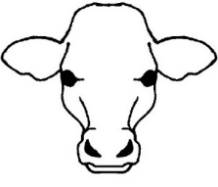
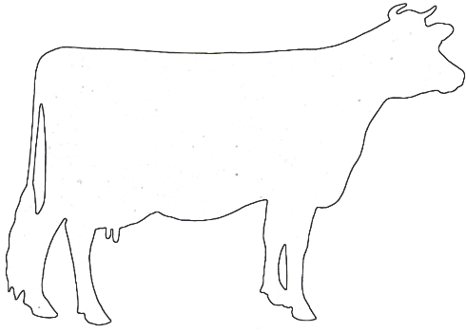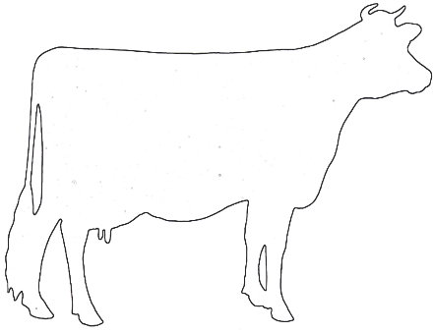
Circle lesions
Mark “X” for
biopsy locations
Check sample type
□Tissue, Fresh | □Blood
□Tissue, Fixed | □Serum
□Feces | □Urine
□Other_____________

Cytologic Exam—Label slides with animal ID & site
Pertinent clinical information __________________________________________________________________________________
__________________________________________________________________________________________________________
□ Cytology -- list site(s) ________________________________________________________________________________
Circle Collection Method: Washes Aspirates Imprints Brushes Scrapings Other ________________
□ Multiple Lymph Node Cytology (2-4 Lymph Nodes) – list site(s) ______________________________________________
________________________________________________________________________________________________________
□ Fluid Analysis, including Cytology – Send Fluid in an EDTA tube along with slides
Circle fluid type: Pleural Peritoneal Synovial Pericardial
□ CSF Analysis – Call for instructions □ Bronchoalveolar Lavage -- Send Fluid in an EDTA tube along with slides

Bacteriology/Mycology □ Feces □ Swab from __________ □ Tissue from ________ □ Urine: __Cystocentesis __Free Catch □Other ____
□ Aerobic Bacterial Culture with up to 3 susceptibilities (fixed price and MUST select before tests run)
□ Aerobic culture □ Anaerobic culture □ Antimicrobial susceptibility □ Blood culture □ Enteric screen □ Fungal culture
□ Abortion screen □ Salmonella □ Johne’s culture □ Johne’s direct PCR fecal Tritrichomonas foetus: □ PCR or □ culture
Treated with antibiotics recently? Y/N Antibiotic used, when, and last dose____________________
Rabies testing: □Brain only □Entire body with brain removal and carcass disposal [send out test]

Lab use only □ Cold Pac □ Frozen □ None □ Room Temp. Sample Condition □ Broken □ Leaked □ Other _______
Toxicology □ Feed___ □ Blood __□ Serum__ □ Fresh Tissue__ □ Other_________________ □ Consult Toxicologist
□ Aflatoxin in milk and liver □ Ammonia □ Calcium serum; ocular fluid □ Cholinesterase activity whole blood, brain □ Copper
□ Ergot Alkaloids in feedstuffs □ Ergot/Fescue Alkaloids in feedstuff □ Lead □Magnesium serum and ocular fluid □ Mycotoxin Screen □ Nitrate □ Rumen pH (included with necropsy) □Vitamin E □ Other__________________

Tube/Name/No. Species Breed Sex Age Tube/Name/No. Species Breed Sex Age
1 |  |  |  |  |  |  | 9
2 |  |  |  |  |  |  | 10
3 |  |  |  |  |  |  | 11
4 |  |  |  |  |  |  | 12
5 |  |  |  |  |  |  | 13
6 |  |  |  |  |  |  | 14
7 |  |  |  |  |  |  | 15
8 |  |  |  |  |  |  | 16
PCR Panels
Bovine Enteric : Bovine Coronavirus, Rotavirus and BVD I and II □
Bovine Respiratory : BVD I and II, Bovine Respiratory Syncytial Virus (BRSV), Bovine Parainfluenza (PI3), IBR □
Bovine Pink Eye : IBR, Mycoplasma bovis, Mycoplasma bovoculi □
Porcine Enteric I (young pigs): Delta Coronavirus, PEDV, Rotavirus A, TGEV □
Porcine Enteric 1I (older pigs): Brachyspira spp., Lawsonia intracellularis, Salmonella spp □
Porcine Respiratory : PRRSV, PCV2, Influenza A and Mycoplasma hyopneumoniae □

Serology 1 ml serum, redtop or separator tube - PCR/Virology EDTA whole blood, CNS fluid, swabs, tissues, feces or as noted

Anaplasmosis □ ELISA □ PCR

Aspergillosis □ AGID

Bluetongue □ ELISA □ PCR

Bovine Coronavirus □ PCR

Bovine Leukosis □ ELISA □ PCR (EDTA blood)

Bovine Respiratory Syncytial Virus □ PCR

BVD (Bovine viral diarrhea) testing options:

IHC (up to 6 fixed ear notches per slide) □

BVD Antigen Capture ELISA serum/fresh ear notch □

PCR (tissues, feces or EDTA blood) □

Serum neutralization (serum) □

Brachyspira spp. □ PCR

Brucella □ Card

Chlamydophila psittaci □ PCR

Chronic Wasting Disease (CWD) □ [send out]

Enteric virus □ Electron microscopy

Epizootic Hemorrhagic Disease Virus (EHD) □AGID □ PCR

Histoplasmosis □ AGID

Infectious Bovine Rhinotracheitis (IBR) □ SN □ PCR

Influenza A □ PCR

Johne’s □ ELISA (serum) □ PCR (fecal sample)

Lawsonia intracellularis □ PCR

Leptospira □ MA (6 serovars) □ PCR

Mycoplasma □ PCR w/sequencing

Mycoplasma bovoculi □ PCR

Mycoplasma hyopneumoniae □ ELISA □ PCR

Neospora □ ELISA

Parainfluenza 3 □ SN □ PCR

Porcine Circovirus (PCV2) □ PCR

Porcine Epidemic Diarrhea Virus (PEDV) □ PCR

PRRSV □ ELISA □ PCR

Pseudorabies (PRV) □ ELISA □ +Brucella

Rotavirus A □ PCR

Salmonella □ PCR

Senecavirus A real time □ PCR

Small Ruminant Lentivirus CAE & OPP □ ELISA

Swine Influenza □ ELISA □ PCR

Toxoplasma □ PCR

TGEV/Porcine respiratory coronavirus □ PCR □ SN

Tritrichomonas foetus □ PCR (InPouch within 48 hours)

Vesicular stomatitis □ SN

West Nile Virus □ PCR

Other ___________________________________

Chemistry – centrifuge and remove  serum/plasma into a separate tube  Specimen type:  □ Serum □ Plasma □ Urine  □ Other _______________  □ MAXI Profile  □ MINI Profile  □ RENAL Profile  □ LIVER Profile  □ Electrolyte and Mineral Panel  □ Urine Protein/Creatinine Ratio  □ Other ______________ | Hematology  □ CBC - Submit EDTA tube & smears (includes  fibrinogen)  □ Fibrinogen  □ Smear Exam for ______________  □ Other _____________  Fecal Examination  □ Flotation □ Fecal Occult Blood  □ Cryptosporidium □ Baermann  Other (specify) ____________ | Urinalysis (For Courier/ Local  Samples Only)  □ Voided □ Cystocentesis  □ Catheter □ Off Floor  □ Complete UA  □ UA w/o Sediment Exam  □ Other (specify) ____________  Endocrinology  □ Progesterone (1 mL serum)
Clinical Pathology Must Provide Date Sample Taken ____________________

Clients submitting specimens are considered to have agreed to VMDL testing procedures, policies and fees (view at: http://www.vmdl.missouri.edu/).
Specimens become the property of the VMDL.

