CVM Veterinary Medical Diagnostic Laboratory Small Animal Submission Form
1-800-UMC-VMDL 800-862-8635 Fax 573-882-1411
Courier Address www.vmdl.missouri.edu US Mail Address
VMDL, 810 E. Campus Loop, Columbia, MO 65211 VMDL, PO Box 6023, Columbia, MO 65205

Acct No _____________ □ Email _______________________ Date Sample Taken _________ Date Sent ________
Phone ___________________ □ Fax ____________________ Owner_____________________________________________
Veterinarian _________________________________________ Address ____________________________________________
Clinic _______________________________________________ City ___________________________ State ___ Zip ________
Address______________________________________________ Phone ________________________________
City ________________________ State______ Zip __________

Animal Name/ID______________ Species ____________ Breed ________________ Sex_______ Age________ Weight_______
No. in Group _______ Sick ____ Dead ___ New introductions? ____ Date Introduced ___________Date noticed sick ________ Euthanized? ____ Method of euthanasia _________Time/ Date of Death ________ Lab results available? ______________

Presenting complaint/Systems of interest: Choose as many as apply
□Normal | □Fever | □Neurological | □Hepatic | □GI/Diarrhea
□Abortion/Repro Failure | □Endocrine | □Sudden Death | □Urinary/urogenital | □Musculoskeletal/lameness
□Edema | □Ocular | □Neoplasia/Mass | □Chronic weight loss | □Cardiac
□Respiratory | □Anorexia | □Dermatological | □Erosion/Vesicular | □Other________________
□Production/Performance decline | □Hematological/Hemorrhage
Clinical/Differential Diagnosis_____________________ Additional History _____________________________________________
____________________________________________________________________________________________________________
____________________________________________________________________________________________________________

□ Necropsy Exam □ Necropsy+Histopathology □ Necropsy+Histo with Laboratory Tests
□ Biopsy □ Mail-In Necropsy with Lab Tests □ Toxicology (additional fees) □Abortion Panel

If skin biopsy, (circle all applicable) erythema, pruritus, macules, papules, pustules, ulceration, crusts, hyperkeratosis, scales, alopecia, lichenification, hyperpigmentation, depigmentation, excoriation, other ______________
Duration ______________Margins inked/Tagged?__________*Treatment ___________________________________
When started/how long? _________________________ Response to therapy? ___ yes ___ no ___ partially
If tumor, Size ____________ Duration _____________ Rate of growth ___ slow ___ fast Recurrence ___yes ___no
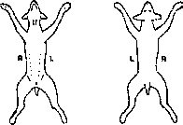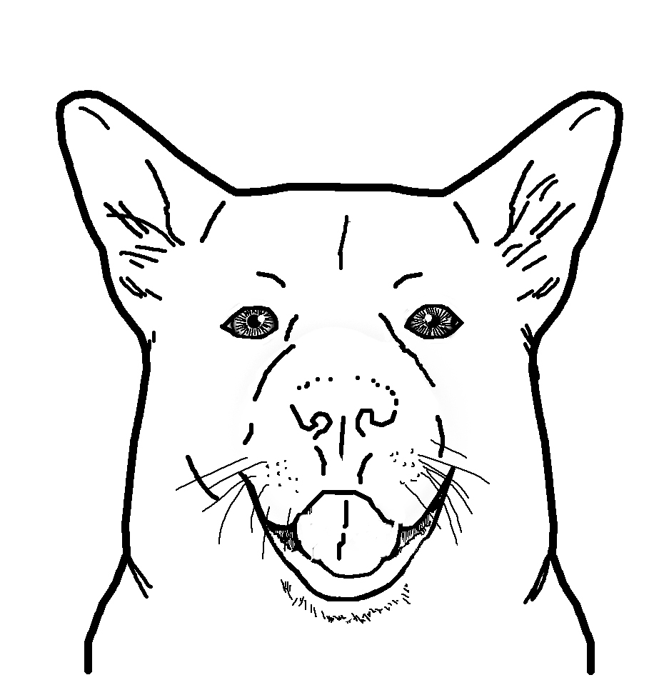
Sample Type
□ Tissue, Fresh | □ Blood
□ Tissue, Fixed | □ Serum
□ Feces | □ Urine
□ Other________________

Circle lesions
Mark “X” for
biopsy locations

Cytologic Exam—Label slides with animal ID & site
Pertinent clinical information _______________________________________________________________________________________________
_______________________________________________________________________________________________________________________
□ Cytology -- Please list site(s) _____________________________________________________________________________________________
Circle Collection Method: Washes Aspirates Imprints Brushes Scrapings Other ______________________________
□ Multiple Lymph Node Cytology (2-4 Lymph Nodes) – Please list sites ___________________________________________________________
_____________________________________________________________________________________________________________________
□ Fluid Analysis, including Cytology – Send Fluid in an EDTA tube along with slides Circle fluid type: Pleural Peritoneal Synovial Pericardial □ CSF Analysis – Call for instructions □ Bronchoalveolar Lavage -- Send Fluid in an EDTA tube along with slides

Bacteriology/Mycology □ Feces □ Swab from __________ □ Tissue from __________ □ Urine: __Cystocentesis __Free Catch □ Other _________

□ Aerobic bacterial culture with up to 3 susceptibilities (fixed price and MUST select before tests run)
□ Aerobic culture □Anaerobic culture □ Antimicrobial susceptibility □ Blood culture □ Enteric screen □ Fungal culture □ Salmonella □ Other______ ______ Treated with antibiotics recently? Y / N Antibiotic used, when, and last dose______________________________________

Lab use only □ Cold Pac □ Frozen □ None □ Room Temp. Sample Condition □ Broken □ Leaked □ Other _________________

All tests not listed. Call the VMDL 1-800-862-8635, or refer to www.vmdl.missouri.edu for more information.

Toxicology □ Pet Food___ □ Blood __□ Serum__ □ Fresh Tissue__ □ Other_________________ □ Consult Toxicologist
□ Lead □ Copper □ Mycotoxin Screen □ Ergot Alkaloids □ Chemical Analysis of Stomach Contents □ Other_______________

Canine Respiratory Panel : Canine Distemper Virus, Influenza A and Canine Adenovirus □

Rabies testing: □Brain only □Entire body with brain removal and carcass disposal [send out test]

Serology 1 ml serum, redtop or separator tube - PCR/Virology EDTA whole blood, CNS fluid, swabs, tissues, feces or as noted

A.phagocytophilum □ IFA □ PCR

Blastomycosis □ AGID

Blastomycosis and Histoplasmosis □ AGID

Borrelia burgdorferi (Lyme Dz) □ IFA □ PCR

Brucella canis □ Card

Canine Coronavirus □ PCR

Canine Distemper □ IgG antibody (IFA) □ IgM (IFA) □ PCR

Canine Distemper Parvo Titer □ ELISA

Canine Heartworm □ ELISA

Canine Parvovirus □ IgG antibody □ IgM antibody □ PCR

Chlamydophila psittaci □ PCR

Coccidiomycosis □ AGID

Cryptococcus □ Antibody □ Antigen-LA

Ehrlichia spp. □ IFA □ PCR

Feline Calicivirus □ Virus Isolation

Feline Heartworm Antibody □ ELISA

Feline Herpesvirus □ PCR

Feline Infectious Peritonitis (FIP) □ IFA □ PCR

FIV Antibody and FeLV Antigen – □ Snap test

Feline Leukemia Virus (Bone marrow, spleen, EDTA whole

blood) □ FA

Histoplasmosis □ AGID

Influenza A □ PCR

Leptospira □ MA (6 serovars) □ PCR

R.rickettsii (RMSF) □ IFA □ PCR

Salmonella □ PCR

Tick Panel: A. phagocytophilum, B. burgdorferi,

E. canis, and R. rickettsii □ IFA □ PCR (EDTA)

Toxoplasma (feline) □ IFA □ PCR

Toxoplasma (all species) □ PCR

West Nile (equine) □ IgM ELISA

West Nile Virus □ PCR

Other ___________________________________

Clinical Pathology Must Provide Date Sample Taken ____________________

Chemistry – centrifuge and  remove serum/plasma into a  separate tube  Specimen type:  □ Serum □ Plasma □ Urine  □ Other _______________  □ MAXI Profile  □ MINI Profile  □ RENAL Profile  □ LIVER Profile  □ Bile Acid Single  □ Bile Acid Pre and Post  □ Urine Protein/Creatinine  □ Other ______________  Coagulation—CALL for  instruction  □ PT  □ PTT | Hematology  □ CBC - Submit EDTA tube &  smears  □ Smear Exam for______________  □ Knott’s test  □ Coombs’ Test  □ Other _____________  Bone Marrow - submit concurrent  CBC or send recent CBC report  □ Bone Marrow Aspirate  □ Bone Marrow Core Biopsy  Fecal Examination  □ Flotation  □ Fecal Occult Blood  □ Direct Fecal Exam  □ Baermann  Other (specify) ____________ | Endocrinology (1 mL serum)  □ Progesterone  □ Total T4  □ TSH (canine)  □ Cortisol – Single  □ ACTH Stimulation –  2 sample  □ Dexamethasone Suppression --  2 Sample  □ Dexamethasone Suppression --  3 Sample  Urinalysis (For Courier/ Local  Samples Only) □ Voided □ Cystocentesis  □ Catheter □ Off Floor  □ Complete UA  □ UA w/o Sediment Exam  □ Other (specify) ____________

Important reminders:

*Please, label all specimens with the tissues present.

*BIOPSY: Tissues should be fixed for 24 hours in a formalin solution of 10:1 tissue volume and then transferred to a smaller container with formalin for shipping.

*Fresh/Fixed: Please, place the fresh tissues is a separate, sealable container to prevent formalin fumes from affecting culture results
*PCR tissues: fresh in whorl packs, EDTA(purple top), whole blood (red top), CNS fluid, swabs, or as noted

Clients submitting specimens are considered to have agreed to VMDL testing procedures, policies and fees (view at: http://www.vmdl.missouri.edu/).
Specimens become the property of the VMDL.

