Packaging and Shipping Supplies
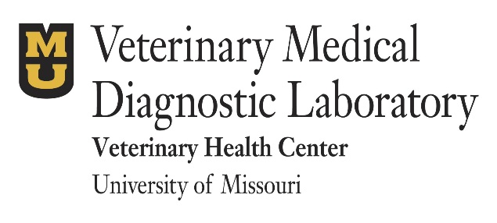

Client Acct No: ______________
Send to:
Veterinarian’s Name: ___________________________________
Clinic Name: __________________________________________
Address: _____________________________________________
City, State, Zip: ________________________________________
Phone: _______________________________________________

Phone: 573-882-6811
800-862-8635

Fax: 573-884-7229

Please note: All samples submitted for testing become the property of the MU VMDL. Prices effective 8/1/23 and are subject to change without notice.

ITEM Price Qty Total

Plastic slide holders (set of 5) | NC
3 tube foam mailer with outer cardboard sleeve (5 sets) | $10.00
Submission forms | NC
US Mail Labels | NC
FedEx Billable Stamp | NC
Biohazard specimen bags with absorbent | NC
FedEx UN 3373 Pak (for biological substance, category B) http://www.fedex.com/us/services/pdf/packaging/UN3373_fxcom.pdf | NC
FedEx Clinical Pak (for exempt animal specimens and other noninfectious, non-toxic samples). http://www.fedex.com/us/packaging/guides/Clinical_fxcom.pdf | NC
3 oz. prefilled formalin containers with secondary containers and return boxes (quantity of 1 = 12 sets) | $42.00
3 oz. and 8 oz. prefilled formalin containers with secondary containers and return boxes (quantity of 1 = 6 sets of each size) | $44.00
8 oz. prefilled formalin containers with secondary containers and return boxes (quantity of 1 = 12 sets) | $46.00
Select preferred method of shipment:
_____FedEx overnight _____FedEx 2nd day _____USPS _____Client pickup _____FedEx Ground

Shipping will be charged to your account. If no method is selected, items will be shipped at the discretion of the lab. Please allow 2-3 days for the order to be processed. All sales final. No returns or refunds.
Prepare specimens for shipment in compliance with applicable regulations and in accordance with requirements specific to the carrier (FedEx, USPS, UPS) and the Department of Transportation.
FOR VMDL USE ONLY: Date Order Received: _______________
Order Filled By: ____________________
Order Shipped: ____________________

Subtotal:
Shipping:
Total Charges:

Bacteriology and Molecular Diagnostics Supplies

Client Acct No: ______________
Send to:
Veterinarian’s Name: ___________________________________
Clinic Name: __________________________________________
Address: _____________________________________________
City, State, Zip: ________________________________________
Phone: _______________________________________________

Phone: 573-882-6811
800-862-8635

Fax: 573-884-7229

Please note: All samples submitted for testing become the property of the MU VMDL. Prices effective 8/1/23 and are subject to change without notice.

BACTERIOLOGY Price Qty Total
BBL CultureSwab Plus with Charcoal | 2.00
E-swab- Regular (Amies liquid media) | 2.00
E-swab- Mini-tip (Amies liquid media) | 2.00
Blood Plate | 1.00
BD-BACTEC Plus | 17.00
Rayon Mini-swabs (no media) | 1.00

MOLECULAR DIAGNOSTICS Price Qty Total
Trichomonas (InPouch®), orders of 1-5 pouches | 12.00
Trichomonas (InPouch®), orders of >5 pouches | 11.00
Universal Viral Transport Collection Kit | 3.00
Synthetic-tipped swabs, sterile, 2/pkg. | .25

Select preferred method of shipment:

_____FedEx overnight _____FedEx 2nd day _____USPS _____Client pickup _____FedEx Ground

Shipping is charged to your account. If no method is selected, items will be shipped at the discretion of the lab. All sales final. No returns or refunds.

Prepare specimens for shipment in compliance with applicable regulations and in accordance with requirements specific to the carrier (FedEx, USPS, UPS) and the Department of Transportation.
Subtotal:
Shipping:
Total Charges:
FOR VMDL USE ONLY: Date Order Received: _______________
Order Filled By: ____________________
Order Shipped: ____________________

